# Exercise: Arrays

You can check your solutions in [Judge](https://judge.softuni.org/Contests/1247).

## Train

You will be given a count of wagons in a train **n**. On the next **n** lines, you will receive how many people will get on that wagon. In the end, print the whole train and the sum of the people on the train.

### Examples

|  |  |
| --- | --- |
| **Input** | **Output** |
| 3  13  24  8 | 13 24 8  45 |
| 6  3  52  71  13  65  4 | 3 52 71 13 65 4  208 |
| 1  100 | 100  100 |

## Common Elements

Write a program that prints common elements in two arrays.

You have to compare the elements of the second array to the elements of the first.

### Examples

|  |  |
| --- | --- |
| **Input** | **Output** |
| Hey hello 2 4  10 hey 4 hello | 4 hello |
| S of t un i  of i 10 un | of i un |
| i love to code  code i love to | code i love to |

## Zig-Zag Arrays

Write a program that creates 2 arrays. You will be given an integer **n**. On the next **n** lines, you get 2 integers. Form 2 arrays as shown below.

### Examples

|  |  |
| --- | --- |
| **Input** | **Output** |
| 4  1 5  9 10  31 81  41 20 | 1 10 31 20  5 9 81 41 |
| 2  80 23  31 19 | 80 19  23 31 |

## Array Rotation

Write a program that receives an array and the number of rotations you have to perform (the first element goes at the end). Print the resulting array.

### Examples

|  |  |
| --- | --- |
| **Input** | **Output** |
| 51 47 32 61 21  2 | 32 61 21 51 47 |
| 32 21 61 1  4 | 32 21 61 1 |
| 2 4 15 31  5 | 4 15 31 2 |

## Top Integers

Write a program to find all the top integers in an array.

A top integer is an integer that is **bigger** than all the elements to its right.

|  |  |
| --- | --- |
| **Input** | **Output** |
| 1 4 3 2 | 4 3 2 |
| 14 24 3 19 15 17 | 24 19 17 |
| 27 9 42 2 13 45 48 | 48 |

## Equal Sums

Write a program that determines if an **element exists in the array** such that the **sum of the elements on its left** is **equal** to the **sum of the elements on its right**. If there are **no elements to the left/right**, their **sum is considered to be 0**. Print the **index** that satisfies the required condition or "**no**" if there is no such index.

### Examples

|  |  |  |
| --- | --- | --- |
| **Input** | **Output** | **Comments** |
| 1 2 3 3 | 2 | At a[2] -> left sum = 3, right sum = 3  a[0] + a[1] = a[3] |
| 1 2 | no | At a[0] -> left sum = 0, right sum = 2  At a[1] -> left sum = 1, right sum = 0  No such index exists |
| 1 | 0 | At a[0] -> left sum = 0, right sum = 0 |
| 1 2 3 | no | No such index exists |
| 10 5 5 99 3 4 2 5 1 1 4 | 3 | At a[3] -> left sum = 20, right sum = 20  a[0] + a[1] + a[2] = a[4] + a[5] + a[6] + a[7] + a[8] + a[9] + a[10] |

## Condense Array to Number

Write a program to read **an array of integers** and **condense** them by **summing** adjacent couples of elements until a **single integer** is obtained. For example, if we have 3 elements {2, 10, 3}, we sum the first two and the second two elements and obtain {2+10, 10+3} = {12, 13}, then we sum again all adjacent elements and obtain {12+13} = {25}.

### Examples

|  |  |  |
| --- | --- | --- |
| **Input** | **Output** | **Comments** |
| 2 10 3 | 25 | 2 10 3 🡪 2+10 10+3 🡪 12 13 🡪 12 + 13 🡪 25 |
| 5 0 4 1 2 | 35 | 5 0 4 1 2 🡪 5+0 0+4 4+1 1+2 🡪 5 4 5 3 🡪 5+4 4+5 5+3 🡪 9 9 8 🡪 9+9 9+8 🡪 18 17 🡪 18+17 🡪 35 |
| 1 | 1 | 1 is already condensed to number |

### Hints

While we have more than one element in the array nums[], repeat the following:

* Allocate a new array condensed[] of size nums.Length-1.
* Sum the numbers from nums[] to condensed[]:
  + condensed[i] = nums[i] + nums[i+1]
* nums[] = condensed[]

The process is illustrated below:

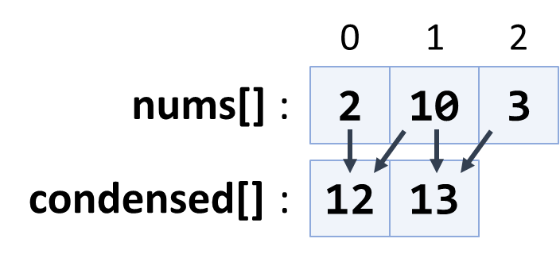

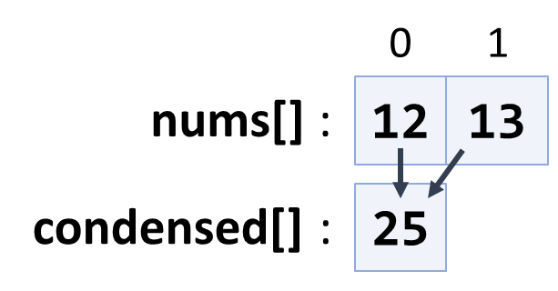

## Magic Sum

Write a program that prints all unique pairs in an array of integers whose sum is equal to a given number.

### Examples

|  |  |
| --- | --- |
| **Input** | **Output** |
| 1 7 6 2 19 23  8 | 1 7  6 2 |
| 14 20 60 13 7 19 8  27 | 14 13  20 7  19 8 |

## Array Modifier

You are given **an array with integers**. Write a program to **modify the elements** after **receiving the following commands**:

* "swap {index1} {index2}" takes **two elements** and **swap their places**.
* "multiply {index1} {index2}" takesthe **element at the 1st index** and **multiplies** **it** **with the element at 2nd index**. **Save the product at the 1st index.**
* "decrease" **decreases** **all elements** in the array **with 1**.

### Input

On the **first input line,** you will be given **the initial array values** separated by a single space.

On the **next lines,** you will receive commands **until** you receive the **command "end"**. The **commands are** as follows:

* "swap {index1} {index2}"
* "multiply {index1} {index2}"
* "decrease"

### Output

**The output** should be printed on the console and consist of **elements** **of the** **modified array** – **separated by a comma and a single space** "**,** ".

### Constraints

* **Elements of the array** will be **integer numbers** in the range **[-231...231].**
* **The count of the array elements** will be in the range **[2...100].**
* **Indexes** **will always be in the range of the array.**

### Examples

|  |  |  |
| --- | --- | --- |
| **Input** | **Output** | **Comments** |
| 23 -2 321 87 42 90 -123  swap 1 3  swap 3 6  swap 1 0  multiply 1 2  multiply 2 1  decrease  end | 86, 7382, 2369942, -124, 41, 89, -3 | 23 -2 321 87 42 90 -123 – initial values  swap 1(-2) and 3(87) ▼  23 87 321 -2 42 90 -123  swap 3(-2) and 6(-123) ▼  23 87 321 -123 42 90 -2  swap 1(87) and 0(23) ▼  87 23 321 -123 42 90 -2  multiply 1(23) 2(321) = 7383 ▼  87 7383 321 -123 42 290 -2  multiply 2(321) 1(7383) = 2369943 ▼  87 7383 2369943 -123 42 90 -2  decrease – all - 1 ▼  86 7383 2369942 -124 41 89 -3 |
| 1 2 3 4  swap 0 1  swap 1 2  swap 2 3  multiply 1 2  decrease  end | 1, 11, 3, 0 |  |

## The Lift

Write a program that **finds a place for the tourist on a lift.**

Every wagon should have **a maximum of 4 people on it**. If a wagon is full, you should direct the people to **the next one with space** available.

### Input

* **On the first line,** you will receive **how many people** are waiting to get **on the lift.**
* **On the second line**, you will receive the **current state of the lift separated by a single space:** **" "**.

### Output

**When there is no more available space left on the lift**, or there are **no more people in the queue**, you should print on the console the final state of the lift's wagons separated by a single space **" "** and one of the following messages:

* If there are no more people and the lift has empty spots, you should print:

**"The lift has empty spots!**

**{wagons separated by ' '}"**

* If there are still people in the queue and no more available space, you should print:

**"There isn't enough space! {people} people in a queue!**

**{wagons separated by ' '}"**

* If the lift is full and there are no more people in the queue, you should print only the wagons separated by a single space **" ".**

### Examples

|  |  |
| --- | --- |
| **Input** | **Output** |
| 15  0 0 0 0 | The lift has empty spots!  4 4 4 3 |
| **Comment** | |
| First state - 4 0 0 0 -> 11 people left  Second state – 4 4 0 0 -> 7 people left  Third state – 4 4 4 0 -> 3 people left | |
| **Input** | **Output** |
| 20  0 2 0 | There isn't enough space! 10 people in a queue!  4 4 4 |
| **Comment** | |
| First state - 4 2 0 -> 16 people left  Second state – 4 4 0 -> 14 people left  Third state – 4 4 4 -> 10 people left, but they're no more wagons. | |